 | Journal of Basic and Environmental Sciences, 8 (2021) 69-77 | ISSN  Online:2356-6388  Print : 2536-9202
Research paper Open Access
Alleviating the adverse effects of salinity hazards on faba beans by some soil amendments and nano-silica foliar application
Maha Badawy Mostafa^{1*}, Mohamed Abd Elaziz¹, Yasser K. Abdel-Monem², Farag Ahmed Ali²
¹Faculty of Science, Menoufia University, Shibin El Kom, Egypt
²Department of Chemistry, Faculty of Science, Menoufia University, Shibin El Kom, Egypt
* Corresponding author: e-mail : mahabadawi_3090@yahoo.com
----------------------------------------------------------------------------------------------------------------------------
Abstract
Background: Soil salinity is one of the major environmental factors affecting agricultural production, while the introduction of certain amendments mitigates the negative impact of salinity on plant growth. The objective of the present study was to evaluate the interactive effect of some soil amendments (i.e. gypsum, compost, and compost tea) on salt affected soil as well as to investigate the possible effects of foliar application of nano-silica (0, 1 and 2 mmol L⁻¹) on alleviating the adverse effects of salinity and the possible mechanisms by which nan-silica could increase faba bean tolerance to salinity. The experiment was conducted during winter season of 2018/2019 in Sakha Agric. Research Station Farm, North Delta, Kafr El-Sheikh Governorate, Egypt.
Results: The results obtained have shown that these amendments, either individually or in combination, significantly improve some of the chemical properties of salt-affected soils (ECe, SAR and ESP) which the application of gypsum + compost + compost tea has a better effect on the reduction of ECe, SAR and ESP at12.91, 27.38 and 24.56 % respectively. On the other hand, data indicate that nano Si foliar application has a highly significantly effect on dry weight of faba bean, proline content and nutrient content. The highest dry weight for grains and straw were (38.80 and 1.94 g plant⁻¹, respectively) belonged to application of G+C+T with nano Si foliar application at a rate of 2 mmole L⁻¹. In addition, the same treatment increased the NPK content in grains and straw of faba beans. While the highest proline content of faba bean (4.66 umole g⁻¹) was achieved due to the application of nano-silica foliar application at a rate of 1 mmole L⁻¹. On the other side, the lowest values (2.61 umole g⁻¹) was recorded with G+C+T without nano-silica foliar application.
Conclusions: Application of foliar nano silica with some soil amendments such as gypsum, compost and compost tea could be successfully used to improve soil salinity, sodicity and crop productivity.
Key words: Gypsum – Compost – Compost tea – Faba bean – Nano-silica.
Received; 13 March 2021, Revised form; 24 March 2021, Accepted; 24 March 2021, Available online 1 April 2021
I. Background:

Salinity is considered as the main stress condition and the serious environmental problem influencing crop production which economically expensive challenges to achieve sustainable development across the world (Nouri et al., 2017). (Machado & Serralheiro, 2017) reported that 20% of cultivated land in the world, and 33% of irrigated land are salt-affected soil. Extensive area of land in the arid regions and, particularly, in Egypt became out of cultivation due to salt accumulation(ASSESS, 2017). Nearly 0.9 M ha⁻¹ of the irrigated areas in Egypt are affected by salinity (El Sharkawy et al. 2017a) Soil salinization is a progressive soil degradation process that reduces soil quality and decreases crop yields and agricultural production (Nawar, Buddenbaum, & Hill, 2015). So, reclamation of salt affected soil is one of the available natural resources to increase the cultivation area in Egypt.
Past literature reported that application of growth stimulants and potassium sulfate could alleviate the salt stress in barley (El-Sharkawy et al., 2017).
Reclamation of a saline-sodic soil demanded to replace the exchangeable Na+ to soluble phase in soil solution by divalent cations to increase soil flocculation. Therefore, leach the soluble salts in soil profile (Szoboszlay et al. 2019). Gypsum (CaSO₄.2H₂O) is considered one of the most important and commonly applied amendment in saline-sodic soil due to its low cost and availability(Kheir, Shabana, & Seleiman, 2018). Studies on the effect of gypsum application on saline-sodic soil reclamation have shown that the soil receiving gypsum at higher rate removes the greatest amount of Na+ from the soil profile and causes a substantial decrease in soil electrical conductivity (EC) and sodium adsorption ration (SAR)(S. Ahmad, Ghafoor, Akhtar, & Khan, 2016). In Egypt, Gypsum used for the reclamation of saline-sodic and sodic soils to remove the Na+ from the soil columns to form neutral salt NaSO₄. Similarly, the addition of organic material in to salt affected soil has been successful in improving soil properties of a saline-sodic soil (Kitila & Chala, 2020). Moreover, the combination of organic application and gypsum proved to act as a preferable soil amendment for reducing soil pH, salinity, and SAR (Sarwar et al., 2011; Kim et al., 2017 and Wafaa Hafez et al., 2017; Bayoumy et al., 2019).
Salinity can also effect on soil microbial community in arid and semi-arid regions (Szoboszlay et al., 2019). Application of gypsum could enhance the role of organic amendments in arid regions, increasing the efficacy of saline sodic soils (Bennett et al., 2015; Sarwar et al., 2011). It can also, improve soil quality in coastal areas if combined with compost (Kim et al., 2017). In addition, interactions of compost and mineral fertilizers, could improve the chemical and biological traits of saline soils (Meena et al., 2016). Biochar could also improve carbon mineralization in saline soils under different regimes of temperature and moisture (Sun et al., 2016).
Currently, using nanoparticles in agriculture is expected to improve the crop productivity by enhancing plant nutrition, precision farming, water use efficiency, crop protection against pest and diseases by molecular tools and techniques, and environmental protection(I. Ahmad & Akhtar, 2019).
Silica (Si) is a “functional” plant nutrient, and its deficiency in crops has been recognized since the 1970s (Islam, Mele, Ki-Young, & Ho-Min, 2018). Silica (Si) is the second most abundant element in the soil and considered beneficial to plant growth and production. Recently, several studies have shown that treatment with silica significantly alleviated environment stresses such as salt, drought, chilling and freezing stress in plants(El-Emary & Amer, 2018). According to Epstein (2009), silica plays an astonishingly large number of diverse roles in plants and does so primarily when the plants are under stressful conditions. Thus, we postulate that the application of nano-SiO₂ improves plant tolerance to salt stress, silica nutrition reduced the inhibitory effect of salinity on plant growth by reducing the Na+ content, increasing CAT and cell wall peroxidase activities, and maintaining the membrane integrity of root cells, as demonstrated by reduced lipid peroxidation. In addition, nano SiO₂ mediates the synthesis of protein, amino acids, nutrient uptake and stimulates antioxidant enzyme activity(Amer & El-Emary, 2018). The present research aims to study the effect of soil amendments on soil salinity, as well as the possible effects of nano-silica foliar application on alleviating the adverse effects of salinity hazards and the possible mechanisms by which nano-silica could increase salinity tolerance for faba bean.
II. Methods
II.1. Experimental location and design
The experiment was conducted during winter season of 2018/2019 in Sakha Agric. Research Station Farm, North Delta, Kafr El-Sheikh Governorate, Egypt to study the effect of some soil amendments on salt affected soil as well as to investigate the possible effects of foliar application of nano-silica on alleviating the adverse effects of salinity and the possible mechanisms by which nan-silica could increase faba bean tolerance to salinity.
The field was prepared for the experiment and arranged in 54 plots (2.5 m x 2 m for each plot).The experimental site were prepared and divided into plots (2.5 m x 2 m).The experimental design was split plot design with three replicates, where six treatments were (gypsum, compost, compost tea, gypsum + compost, gypsum + compost tea and gypsum + compost + compost tea) assigned as the main plots, while the nano-silica treatments (0, 1 and 2 mmol L⁻¹) were assigned as the sub-plots.
Gypsum requirements (6.34 ton /fed) according to gypsum requirements (GR) and compost was added at a rate of 8 ton/fed as recommended by Ministry of Agriculture. Gypsum and compost were thoroughly mixed with the surface soil layer (0-30 cm) before cultivation. While Compost tea has mixed with water irrigation after sowing and next irrigation in a rate of 40 L/fed. The physiochemical composition of compost and compost tea were listed in Table (1).
Gypsum requirements were determined according to (FAO and IIASA, 2000). These amounts are sufficient to reduce the initial ESP to 10% for the soil matrix in the surface layer according to the following equation:
GR = (ESP_{i} – ESP_{f}) x CEC x 1.72× (100/purity)
Where Gr: gypsum requirement (ton fed⁻¹), ESP_{i}: initial soil ESP, ESP_{f}: The required soil ESP (10), CEC: cation exchange capacity (cmolc kg⁻¹) and purity (85%).
Table (1): Some soil physical and chemical properties before planting:
Characteristics | Rice straw compost | Compost tea
EC dS/m/ 25 C^{0 *}  Soil pH *  Organic matter %  Total carbon %  Total N %  C/N ratio  Total P %  Total K % | 3.21  7.9  16.61  9.64  1.33  7.13  0.51  0.68 | 2.75  8.11  33.76  19.58  3.4  5.76  0.71  0.75
Available macro- elements (mg kg⁻¹): | 38.27  15.64  755.32 | 67.89  18.13  645.44
Available N
Available P
Available K
Available micro-elements (mg kg⁻¹) | 72.43  19.97  44.65  2.89 | 172.3  41.3  23.1  9.5
Fe
Zn
Mn
Cu

Nano-silica (about 12 nm particle size) foliar application will apply to test plant (Faba beans) in three concentrations (0, 1 and 2 mmol/l) at different sensitive growth stages (germinations, flowering and grain filling).
The grains of faba beans (Vicia Faba) variety (Sakha 1) were inoculated just before sowing with rhizobium and sown at the rate of 60 kg grains fed⁻¹ on Nov. 14th, 2018 and harvesting on feb. 18th, 2019. All plots received the recommended dose of NPK fertilizers other agricultural practices performed according to the Ministry of Agric. recommendation for faba beans in North Delta, during seedling and vegetative stage.
II.2. Soil analysis
Soil samples from the surface layer (0-30 cm) taken before planting and after harvesting from each experimental unit. Soil samples were air-dried, crushed, and sieved to pass through a 2.0-mm. Soil chemical properties was analyzed according to the standard methods outlined by Page et al., (1982) and Cottenie et al., (1982). While the physical characteristics were determined as soil texture and bulk density as described by Briggs (1977).Some soil characteristics before cultivation are illustrated in Table (2).
Sodium adsorption ratio (SAR) was calculated according to Richards (1954) where the concentrations of cations are expressed in mmol.L-1 as the follows:
SAR= Na⁺ √ (Ca²⁺ +Mg²⁺)/2
While Exchangeable sodium percentage (ESP) was calculated according to the equation of Rashidi and Seilsepour (2008):
𝐸𝑆𝑃 = 1.95 + 1.03 SAR

Table (2): Some chemical and physical Characteristics of the experimental site before cultivation.
Characteristics | Soil depth
 | 0-30
EC dS/m/ 25 C^{0 *}  Ca⁺⁺ meq L⁻¹  Mg⁺⁺ meq L⁻¹  Na⁺ meq L⁻¹  K⁺ meq L⁻¹  Co₃⁻⁻ meq L⁻¹  Hco₃⁻ meq L⁻¹  Cl⁻ meq L⁻¹  SO₄⁻⁻ meq L⁻¹  SAR  ESP  Soil pH **  Organic matter %  Total carbon % | 6.25  9.94  6.13  45.94  0.53  0.0  5.0  32.16  25.37  16.21  18.65  8.10  1.51  0.88
Available macro- elements (mg kg⁻¹): | 22.56  12.1  324.8
Available N
Available P
Available K
Available micro-elements (mg kg⁻¹) | 40.21  7.57  36.77  0.19
Fe
Zn
Mn
Cu
Particle size distribution (%) | 16.32  30.52  53.16  Clayey
Sand
Silt
Clay
Texture grade
Bulk density (Mg/m³) | 1.36
* EC was determined in saturated soil paste extract. **pH was determined in soil suspension (1:2.5)

II.3. Plant sampling and analysis
At maturity stage, all plant samples in one-meter square from each treatment was taken for estimate straw and grain dry weight in g plant⁻¹. Total nitrogen, phosphorus, potassium and sodium were determined in the plant digestion according to the method described by (Faithfull, 2002). Free proline content was determined in dry matter (DM) of faba bean grains using Spectrophotometer according to (Bates, Waldren, & Teare, 1973).
II.4. Statistical analysis:
The obtained results subjected to statistical analyses according to the procedure outlined by Cochran and Cox (1960), and significant differences weighted by LSD test at 0.05 level of probability.
III. Results and Discussions
III.1. Effect of soil amendments on some chemical properties of soil
Soil chemical properties showed remarkable changes with soil amendments as shown in Table (3). The ameliorating effects are mainly associated with decreasing of salts in the soil profile where enhance growth rate in plants is observed. The results of soil chemical properties are as follows:
III.1.1. Soil Electrical Conductivity (ECe)
The soil additives led to enhance soil salinity (Table 3). Application of gypsum in combination with compost and compost tea (G+C+T) recorded the lowest ECe with value of 5.66 dS m⁻¹ without significant differences found with application of gypsum in combination with compost tea (G+T) after faba beans harvest. The check plot (untreated soil) recorded the highest ECe value (6.33 dS m⁻¹).
Consequently, the changes in ECe after different treatments application in compared to the initial ECe are presented in Fig. (1) indicating that G+C+ T treatment has the better effect in decreasing the ECe with 12.91% followed by G+T with value of 11.02% while the control treatment recorded the lowest change in ECe with value of 2.64%. These results are in the same line with Sarwar et al., (2011); Kim et al., (2017) and Wafaa Hafez et al., (2017); Bayoumy et al., (2019). It has been reported that gypsum application combined with compost or compost tea decreasing electrical conductivity.

Table (3): Effect of irrigation with different saline water levels on some soil chemical properties after first and second cultivation seasons:
Soil amendments | EC_{e}  (dS m⁻¹) | SAR | ESP
A | 6.00 | 13.97 | 16.34
T | 5.79 | 13.30 | 15.65
C | 5.83 | 13.35 | 15.70
G | 5.64 | 11.98 | 14.29
G+T | 5.57 | 11.91 | 14.22
G+C | 5.61 | 11.95 | 14.26
G+C+T | 5.49 | 11.82 | 14.13
LSD_{0.05} | 0.09 | 0.04 | 0.12

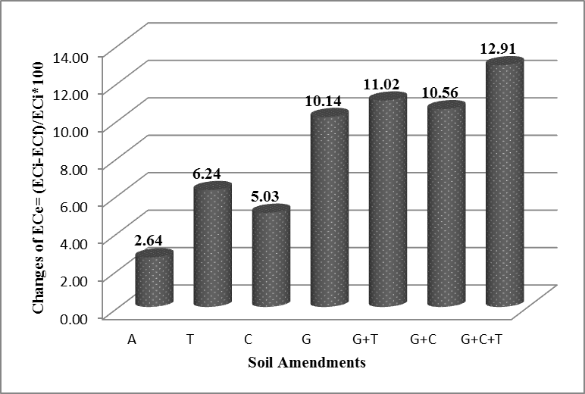
** A (control); T (compost tea) ; C (compost) and G (gypsum).
Fig. (1): Changes of ECe (%) as affected by different soil amendments.

III.1.2. Soil sodicity (SAR and ESP)
The results related to soil SAR and ESP are given in Table (3). Data revealed that the application of gypsum in combination with compost and compost tea (G+C+T) significantly alleviated soil sodicity after faba beans harvesting.
The G+C+T treatment exhibited the lowest values of SAR and ESP recording 11.82 and 14.13 respectively, in compared to check plot (A) which recorded 13.97 and 16.34 for SAR and ESP. The decrease on ESP and SAR with the application of gypsum in combination with compost and compost tea (G+C+T) is the amelioration of soil porosity or may be a cause of decreasing Na⁺ or increase of Ca⁺² (Kim et al. 2017). It has been reported that the combined of organic and inorganic amendments to sodic soil resulted in reducing SAR and therefore ESP of soil Sarwar et al., (2011); Bayoumy et al., (2019). Shaaban et al. (2013) reported that when organic matter decomposition, CO₂ is increased, and the amounts of H freed which increased the decay of CaCO₃ and unleashes more Ca 2 that exchange with Na ions on soil colloids.
An overall change in SAR and ESP (%) after faba beans harvesting was observed from Fig. (2&3) were significantly (p ≤ 0.05) decreased with G+C+T in compare with other treatments recording 27.38% and 24.56% respectively.

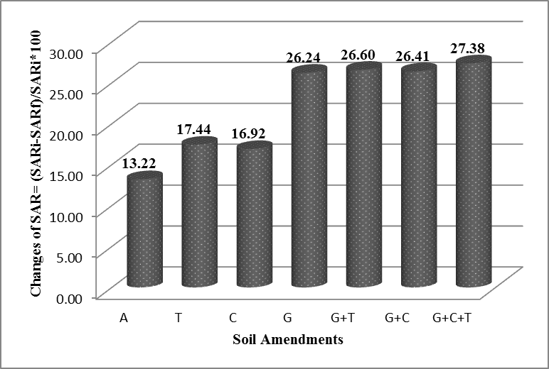
Fig. (2): Changes of SAR (%) as affected by different soil amendments.
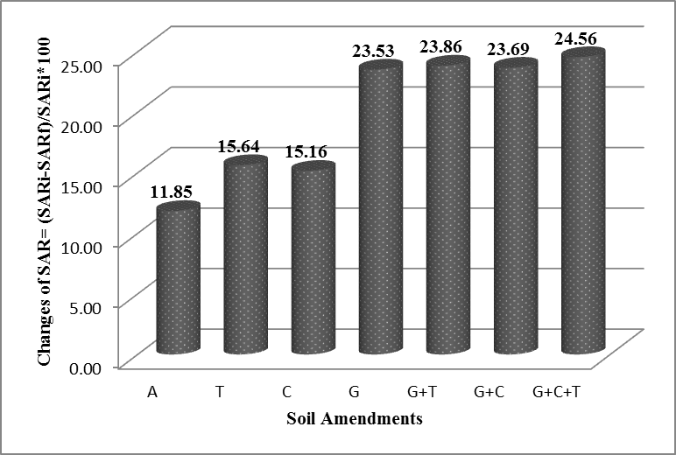
Fig. (3): Changes of ESP (%) as affected by different soil amendments.

III.1.3. Dry weight of grains and straw yield (g/ plant)
As seen in Table 4, the effect of soil amendments and nano Si foliar application were significant on dry weight of grains and straw yield at 5% level probability.
The highest values of dry weight for grains and straw (2314 kg fed⁻¹ and 1.66 g plant⁻¹), respectively were obtained with application of G+C+T while the lowest values (1945.67 kg fed⁻¹ and 0.87g plant⁻¹), respectively were detected under check plot (A). The severe reduction in faba bean yield with saline soil is a reflection of severe reductions in leaves area and this may be ascribed to the retardation in water uptake, the inhibition in cell division and/or cell enlargement, the disruption in cell structure and/or imbalance in metabolic activities, the particular biosynthesis of endogenous phytohormones, photosynthesis, nucleic acids and protein. Gypsum and straw compost have the potential to reduce salt stress and improve crop growth in salt affected soils, These results are in harmony with those recorded by(Lee, Seo, Ro, & Yun, 2016), (Cao, Gao, Li, & Tian, 2019).
On the other hand, data indicate that nano Si foliar application has a highly significantly effect on dry weight of faba bean. The dry weight of faba bean (g plant⁻¹) clearly increased approximately according to the following descending order: nano Si foliar application at a rate of 2 mmole L⁻¹˃ nano Si foliar application at a rate of 1 mmole L⁻¹˃ without foliar application. These results are in harmony with those recorded by(Qados & Moftah, 2015),(El-Emary & Amer, 2018).

Table (4): Effect of soil amendments and nano silica foliar application on faba bean dry weight (g plant⁻¹) and proline content (umole g⁻¹ DM) .
Parameters |  | Grain yield  (kg fed⁻¹) | Straw yield  (g plant⁻¹) | Proline  (umol g⁻¹ DM)
Treatments
Soil amendments | A | 1945.67 | 0.87 | 4.43
 | T | 2054.33 | 1.26 | 4.22
 | C | 2105.33 | 1.06 | 3.78
 | G | 2157.33 | 1.33 | 3.15
 | G+T | 2200.00 | 1.51 | 3.07
 | G+C | 2250.00 | 1.37 | 3.13
 | G+C+T | 2314.00 | 1.66 | 2.90
 | LSD_{0.05} | 2.3516 | 0.00752 | 0.05621
Nano Si foliar application | 0 | 2099.71 | 1.04 | 3.22
 | 1 | 2145.00 | 1.30 | 3.58
 | 2 | 2195.29 | 1.54 | 3.79
 | LSD_{0.05} | 2.6715 | 0.00756 | 0.04196

Data in Table (5) revealed that the interaction between treatments on dry weight of faba bean had a significant effect on the 5% levels. The mean comparison of simple effects showed that the highest dry weight for grains and straw were (2372 kg fed⁻¹ and 1.94 g plant⁻¹, respectively) belonged to application of G+C+T with nano Si foliar application at a rate of 2 mmole L⁻¹, while check plot (A) give the lowest mean values (1903 kg fed⁻¹ and 0.67g plant⁻¹) for dry weight for grains and straw, respectively.
Table (5): Effect of interaction between soil amendments and nano silica foliar application on faba bean dry weight (g plant⁻¹) and proline content (umole g⁻¹ DM).
Nano  Si foliar app. | Soil amendments | Grain yield  (kg fed⁻¹) | Straw yield  (g plant⁻¹) | Proline  (umol g⁻¹ DM)
Without | A | 1903 | 0.67 | 4.13
 | T | 2005 | 1.00 | 3.99
 | C | 2065 | 0.83 | 3.49
 | G | 2120 | 1.08 | 2.83
 | G+T | 2155 | 1.21 | 2.71
 | G+C | 2190 | 1.10 | 2.76
 | G+C+T | 2260 | 1.42 | 2.61
1(mmole L⁻¹) | A | 1941 | 0.88 | 4.51
 | T | 2055 | 1.27 | 4.23
 | C | 2112 | 1.06 | 3.77
 | G | 2157 | 1.35 | 3.21
 | G+T | 2200 | 1.51 | 3.16
 | G+C | 2240 | 1.39 | 3.21
 | G+C+T | 2310 | 1.61 | 2.98
2 (mmole L⁻¹) | A | 1993 | 1.06 | 4.66
 | T | 2103 | 1.50 | 4.45
 | C | 2139 | 1.30 | 4.08
 | G | 2195 | 1.56 | 3.42
 | G+T | 2245 | 1.80 | 3.33
 | G+C | 2320 | 1.62 | 3.44
 | G+C+T | 2372 | 1.94 | 3.12
F-test |  | ** | ** | **

III.1.4. Proline content of faba bean
It is evident from the results (Table 4) that the proline content of faba bean was significantly increased as a result of application of soil amendments comparing to that in the untreated soil. The proline content of faba bean was decreased from 4.43 umole g⁻¹ in untreated soil to 2.90 umole g⁻¹ in plants treated by G+C+T.
In regard to the effect of nano-silica foliar application at a rate of 1 or 2 mmole L⁻¹ increased the proline content of faba bean to 3.58 or 3.79 umole g⁻¹, respectively comparing to that without foliar application (3.22 umole g⁻¹). Thus, the possible mechanisms by which Si increase salinity tolerance of faba bean plant and enhances the plant growth. Also, Nano-Silica application resulted in increasing proline content in salt stressed faba bean plant. The high cytoplasmic concentrations of inorganic solutes such as proline (Cavalieri & Huang, 1979) accumulated in salt stressed plants, were possibly acting either as buffer against osmotic imbalance caused by high vacuolar ion concentration or as a protective agent for cytoplasmic enzymes (Pollard & Jones, 1979). Therefore, increasing the accumulation of proline as a result of nano-silica application to the salt stressed plant offers a great promise as one of the major physiological mechanism of salt tolerance in faba bean plant.
In addition, data in Table 5 indicate that, the proline content of faba bean significantly affected by the interaction of soil amendments with nano-silica foliar application according to the statistical analysis. Meanwhile, the highest proline content of faba bean (4.66 umole g⁻¹) was achieved due to the application of nano-silica foliar application at a rate of 1 mmole L⁻¹. On the other side, the lowest values (2.61 umole g⁻¹) was recorded with G+C+T without nano-silica foliar application. These results are in harmony with those recorded by(Qados, 2015)and(Hasan, Soliman, Baka, & Shabana, 2020).
III.1.6. Nutrient’s content of faba beans plant
Nutrient contents (N, P, K and Na) in grains and straw of faba beans plants are shown in Table (5). There were significant differences (p<0.05) in faba beans plant nutrients contents as affected by different soil amendments and nano Si foliar application.
The results indicated that the G+C+T treatment N, P and K content in straw with increase percent of 88.14, 151.79 and 52.62%, respectively, while the same treatment increased NPK content in grains by 81.83, 86.54 and 44.60%, respectively in compared to check plot (A). But the Na content in straw and grains decreased by 69.39 and 90.85% in compared to check plot (A).
Concerning the effect of foliar application, the Nano-Si foliar application displayed an overall improvement in Nutrient contents (N, P, K and Na) than without foliar application. The Nano-Si foliar application at a rate of 2 mmol L⁻¹ significantly (p<0.05) increased N, P and K content in straw by 32.38, 22.40 and 3.68%, in grains by 19.09, 6.08 and 6.26%, respectively in compared to without foliar application, but, its decreased the Na content in straw and grains by 25.38 and 30.54% , respectively in compare to without foliar application. These results are in agreement with that obtained by (Qados, 2015; Sabaghnia & Janmohammadi, 2015; Tantawy, Salama, El-Nemr, & Abdel-Mawgoud, 2015), they found that Nano-Silica application led to increase K uptake and decrease Na uptake by faba bean plant which result in osmotic adjustment that encourage nutrients uptake and hence increase plant tolerance to salinity.

Table (6): Effect of soil amendments and nano silica foliar application on nutrient contents (%) in grains and straw of faba beans.
Parameters |  | N (%) |  | P (%) |  | K (%) |  | Na (%)
Treatments |  | Straw | Grain | Straw | Grain | Straw | Grain | Straw | Grain
Soil amendments (VC) | A | 2.35 | 2.82 | 0.14 | 0.34 | 1.00 | 0.70 | 3.06 | 2.66
 | T | 3.41 | 4.01 | 0.25 | 0.55 | 1.12 | 0.82 | 2.55 | 2.16
 | C | 3.25 | 3.89 | 0.19 | 0.49 | 1.13 | 0.90 | 2.91 | 2.51
 | G | 2.80 | 3.33 | 0.17 | 0.47 | 1.39 | 0.76 | 2.3 | 1.93
 | G+T | 3.72 | 4.32 | 0.25 | 0.55 | 1.42 | 0.91 | 1.85 | 1.45
 | G+C | 3.35 | 3.85 | 0.21 | 0.51 | 1.42 | 0.94 | 2.18 | 1.77
 | G+C+T | 4.04 | 4.64 | 0.30 | 0.56 | 1.48 | 0.98 | 1.72 | 1.30
 | LSD_{0.05} | 0.03500 |  | 0.00102 | 0.00419 |  |  | 0.0985 | 0.0308
Nano Si foliar app. (mmole L⁻¹) | 0 | 2.58 | 3.51 | 0.19 | 0.48 | 1.26 | 0.83 | 2.63 | 2.23
 | 1 | 2.99 | 3.85 | 0.22 | 0.51 | 1.28 | 0.86 | 2.38 | 1.98
 | 2 | 3.42 | 4.17 | 0.24 | 0.51 | 1.31 | 0.88 | 2.09 | 1.71
 | LSD_{0.05} | 0.03265 |  | 0.0008 | 0.00191 |  |  | 0.846 | 0.0464

Fig. (4&5) illustrated that N, P, K and Zn content in straw and grains were affected significantly (P<0.05) by gypsum, compost and nano Si foliar application individually or combined as compared to the check plot. Meanwhile, data reveal that the N, P, K content in straw and grains clearly increased approximately with G+C+T+nanoSi₂, while Na content in straw and grains decreased with the same treatment. These results are in harmony with those recorded by(Qados & Moftah, 2015).
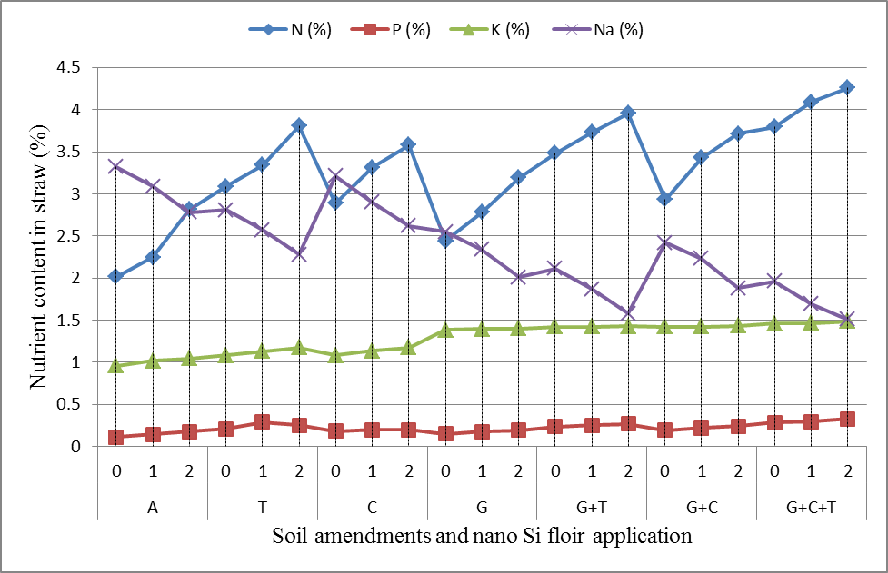
Fig. (4): Effect of gypsum (G), compost (C), compost tea (T) and nano Si foliar application and its combination on NPK and Na content in faba beans straw

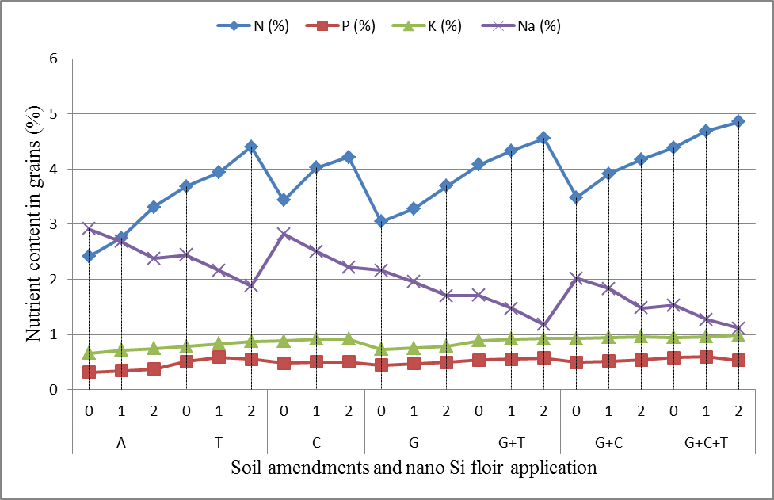
Fig. (5): Effect of gypsum (G), compost (C), compost tea (T) and nano Si foliar application and its combination on NPK and Na content in faba beans grains

IV. Conclusion
It could be concluded from this study that the added soil amendments and/or foliar application of nano silica alleviated the adverse effect of salinity on faba beans productivity, and the combined application of them was more effective on faba beans growth under salt stress. However, there were obvious decreases in ECe, SAR and ESP for soil treated by soil amendments.
Acknowledgements
Authors are thankful for Soils, Water and Environment, Agricultural Research Center for financial support

Declarations
Competing of interest: No conflict

References

Ahmad, I., & Akhtar, M. S. (2019). Use of Nanoparticles in Alleviating Salt Stress Salt Stress, Microbes, and Plant Interactions: Causes and Solution (pp. 199-215): Springer.
Ahmad, S., Ghafoor, A., Akhtar, M. E., & Khan, M. Z. (2016). Implication of gypsum rates to optimize hydraulic conductivity for variable‐texture saline–sodic soils reclamation. Land degradation & development, 27(3), 550-560.
Amer, M., & El-Emary, F. A. (2018). Impact of Foliar with Nano-silica in Mitigation of Salt Stress on Some Soil Properties, Crop-Water Productivity and Anatomical Structure of Maize and Faba Bean. Environment, Biodiversity and Soil Security, 2(2018), 25-38.
ASSESS, T. (2017). Prediction of Reclamation Processes in Some Saline Soils of Egypt.
Bates, L. S., Waldren, R. P., & Teare, I. (1973). Rapid determination of free proline for water-stress studies. Plant and soil, 39(1), 205-207.
Bennett, J.M., Cattle, S.R., Singh, B. and Quilty, J.R. (2015). Influence of gypsum enhanced chicken-manure-and-wheat-straw compost on amelioration of an irrigated sodic brown vertisol–laboratory experiment. Arid Land Research and Management, 29(4),: 415-431.
Cao, Y., Gao, Y., Li, J., & Tian, Y. (2019). Straw composts, gypsum and their mixtures enhance tomato yields under continuous saline water irrigation. Agricultural Water Management, 223, 105721.
Cavalieri, A. J., & Huang, A. H. (1979). Evaluation of proline accumulation in the adaptation of diverse species of marsh halophytes to the saline environment. American Journal of Botany, 66(3), 307-312.
El-Emary, F., & Amer, M. (2018). Role of Nano-Silica in Amelioration Salt Stress Effect on some Soil Properties, Anatomical Structure and Productivity of Faba Bean (Vicia faba L.) and Maize (Zea mays L.) Plants. Journal of Plant Production, 9(11), 955-964.
EL-Sharkawy, M.S., EL-Beshsbeshy, T.R., Hassan, S.M., Mahmoud, E.K., Abdelkader, N.I., Al-Shal, R.M. and Missaoui, A.M. (2017a). Alleviating Salt Stress in Barley by Use ofPlant Growth Stimulants and Potassium Sulfate. Journal of Agricultural Science, 9(4).
Faithfull, N. T. (2002). Methods in agricultural chemical analysis: a practical handbook: Cabi.
Hasan, K. A., Soliman, H., Baka, Z., & Shabana, Y. M. (2020). Efficacy of nano-silica in the control of chocolate spot disease of Vicia faba L. caused by Botrytis fabae. Egyptian Journal of Basic and Applied Sciences, 7(1), 53-66.
Islam, M. Z., Mele, M. A., Ki-Young, C., & Ho-Min, K. (2018). The effect of silica and boron foliar application on the quality and shelf life of cherry tomatoes. Zemdirbyste-Agriculture, 105(2).
Kheir, A., Shabana, M., & Seleiman, M. (2018). Effect of Gypsum, Sulfuric Acid, Nano-Zeolite Application on Saline-Sodic Soil Properties and Wheat Productivity under Different Tillage Types. Journal of Soil Sciences and Agricultural Engineering, 9(12), 829-838.
Kim, Y.J., Choo, B.K. and Cho, J.Y. (2017). Effect of gypsum and rice straw compost application on improvements of soil quality during desalination of reclaimed coastal tideland soils: ten years of long-term experiments. Catena, 156: 131-138.
Kitila, K., & Chala, A. (2020). Evaluation of combined and sole effect of application of gypsum and compost for soil salinity management at small scale irrigation farm in Dugda District of East Shewa Zone, Oromia, Ethiopia. Discovery Agriculture, 6(15), 19-29.
Lee, J., Seo, D., Ro, H., & Yun, S. (2016). Yield response of Chinese cabbage to compost, gypsum, and phosphate treatments under the saline-sodic soil conditions of reclaimed tidal land. Korean Journal of Horticultural Science & Technology, 34(4), 587-595.
Machado, R. M. A., & Serralheiro, R. P. (2017). Soil salinity: effect on vegetable crop growth. Management practices to prevent and mitigate soil salinization. Horticulturae, 3(2), 30.
Meena, M.D., Joshi, P.K., Narjary, B., Sheoran, P., Jat, H.S., Chinchmalatpure, A.R., Yadav, R.K. and Sharma, D.K. (2016). Effects of municipal solid waste compost, rice-straw compost and mineral fertilisers on biological and chemical properties of a saline soil and yields in a mustard–pearl millet cropping system. Soil Research, 54(8): 958-969.
Nawar, S., Buddenbaum, H., & Hill, J. (2015). Estimation of soil salinity using three quantitative methods based on visible and near-infrared reflectance spectroscopy: a case study from Egypt. Arabian Journal of Geosciences, 8(7), 5127-5140.
Nouri, H., Chavoshi Borujeni, S., Nirola, R., Hassanli, A., Beecham, S., Alaghmand, S., . . . Mulcahy, D. (2017). Application of green remediation on soil salinity treatment: A review on halophytoremediation. Process Safety and Environmental Protection, 107, 94-107. doi:https://doi.org/10.1016/j.psep.2017.01.021
Pollard, A., & Jones, R. W. (1979). Enzyme activities in concentrated solutions of glycinebetaine and other solutes. Planta, 144(3), 291-298.
Qados, A. M. A. (2015). Mechanism of nanosilica-mediated alleviation of salinity stress in faba bean (Vicia faba L.) plants. Journal of Experimental Agriculture International, 78-95.
Qados, A. M. A., & Moftah, A. E. (2015). Influence of silica and nano-silica on germination, growth and yield of faba bean (Vicia faba L.) under salt stress conditions. Journal of Experimental Agriculture International, 509-524.
Sabaghnia, N., & Janmohammadi, M. (2015). Effect of nano-silica particles application on salinity tolerance in early growth of some lentil genotypes/Wpływ nanocząstek krzemionki na tolerancję zasolenia we wczesnym rozwoju niektórych genotypów soczewicy. Annales UMCS, Biologia, 69(2), 39-55.
Sarwar, G., Ibrahim, M., Tahir, M.A., Iftikhar, Y., Haider, M.S., Noor-Us-Sabah, N.U.S., Han, K.H., Ha, S.K. and Zhang, Y.S. (2011). Effect of compost and gypsum application on the chemical properties and fertility status of saline-sodic soil. Korean Journal of Soil Science and Fertilizer, 44(3):510-516.
Sun, J., He, F., Zhang, Z., Shao, H. and Xu, G. (2016). Temperature and moisture responses to carbon mineralization in the biochar-amended saline soil. Science of The Total Environment, 569: 390-394.
Szoboszlay, M., Näther, A., Liu, B., Carrillo, A., Castellanos, T., Smalla, K., Jia, Z. and Tebbe, C.C. (2019). Contrasting microbial community responses to salinization and straw amendment in a semiarid bare soil and its wheat rhizosphere. Scientific reports, 9: 1-11.
Tantawy, A., Salama, Y., El-Nemr, M., & Abdel-Mawgoud, A. (2015). Nano silica application improves salinity tolerance of sweet pepper plants. International Journal of ChemTech Research, 8(10), 11-17.
Page, A.L., R. H. Miller and D.R. Keeney (1982). Methods of Soil Analysis”. Part 2: Chemical and microbiological properties. second edition, Amer Soc. Of Agron. Madison, Wisconsin, USA.
Cottenie, A., Verlo, M., Kjekens, L. and Camerlynch, R. (1982). Chemical Analysis of Plant and Soil. Laboratory of Analytical Agrochemistry. State University, Gent, Belgium, (42):80-284.
Briggs, D.J. (1977). Soils, Sources and Methods in Geography. Butterworths, London.
Shaaban, M., Abid, M. and Abou-Shanab, R.A.I. (2013). Amelioration of salt affected soils in rice paddy system by application of organic and inorganic amendments. Plant, Soil and Environment, 59(5): 227-233.
Richards L.A. (1954). Diagnosis and improvement of saline and alkali soils. USDA Agricultural Handbook No. 60, US Department of Agriculture, Washington DC. 160 p.
Rashidi M. and M. Seilsepour, (2008). Modeling of soil exchangeable sodium percentage based on soil sodium adsorption ratio. Arpn Journal of Agricultural and Biological Science. 3 (4): 1990-6145.
FAO and IIASA (2000). Diagnosis and improvement of saline and alkali sols, USDA Handbook No 60, U.S. Salinity Lab. Staff (1954), Washington.

